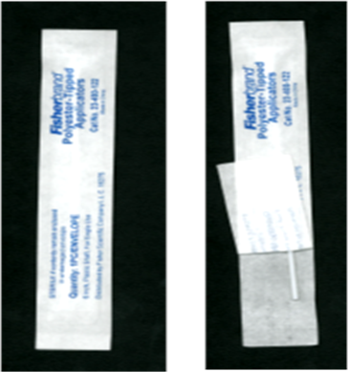**Vaginal Self-Collected Vaginal Swab for MTN-025**





**1)** Wash & dry hands,

Then undress from the

waist down.

**2)** Remove Cap from vial.

Place Cap nearby.

**3)** Open swab envelope on the end

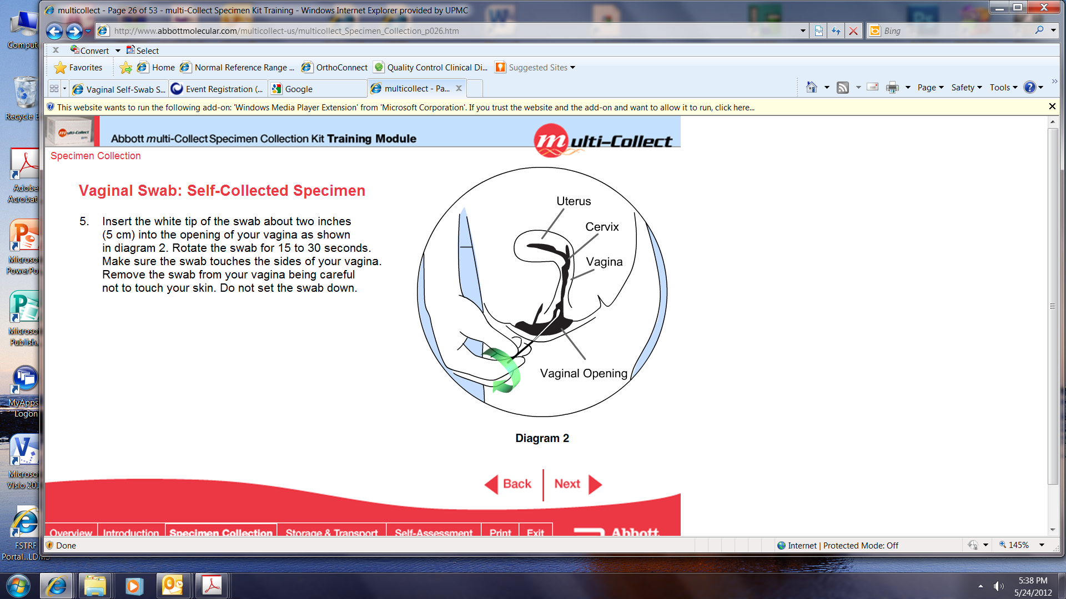   **opposite** of the soft tip. **4)** Grasp swab as pictured. **5)** Separate the labia with one

hand, use other hand to hold the plastic swab shaft between

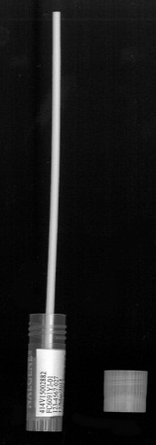 thumb and forefinger.



**6)**Pictured:

* Insert the soft tip of the swab into your vagina

approximately 2 inches (~length of your little finger).

* Spin the swab for 10 seconds (counting thousand 1,

thousand 2, thousand 3…) in a circular motion

attempting to touch all walls of the vagina.

* Remove slowly while still spinning swab!

**7)** Insert swab into vial

(hold upright) **8)** Place finger or thumb on the swab shaft so swab does

**NOTE: If the swab is dropped, please ask for**  not come out. Bend shaft back & forth to break off. **9)**  Place cap on cryovial. **a new swab and repeat the entire process** **above.** Give vial to study staff.

MTN-025 Self-collected Vaginal Swab Instructions, 23Jun2016